**EX NO: 10 Command Line Arguments (word count)**

**Date :**

**AIM**

Write a Python program that does counting of words in a file. The program should accept multiple file names when it is invoked and duely process them.

input: ‘python’ output: 1

input: "python is great language" output: 4

**ALGORITHM**

**Step 1:** Get the filename as command line argument   
**Step 2:** Open and read the file content (text)  
**Step 3:** Split the text with space delimiter ‘ ‘  
**Step 4:** Count and print the number of words after the split

**FLOWCHART**

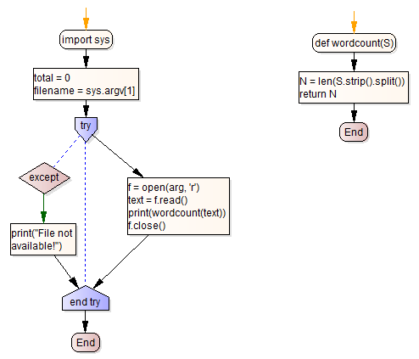

**SOURCE CODE**

import sys

def wordcount(S):

N = len(S.strip().split())

return N

filename = sys.argv[1]

try:

f = open(arg, 'r')

text = f.read()

print(wordcount(text))

f.close()

except:

print("File not available!")

**OUTPUT**

sample.txt

python is great language

$ python3 wc.py sample.txt

**4**

**RESULT**

Thus the python program for counting of words in a file using command line arguments was executed and verified successfully.